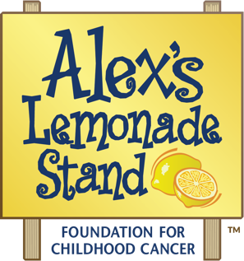
Participating in The Million Mile Virtual Fundraiser
with Staff, Students, and Families

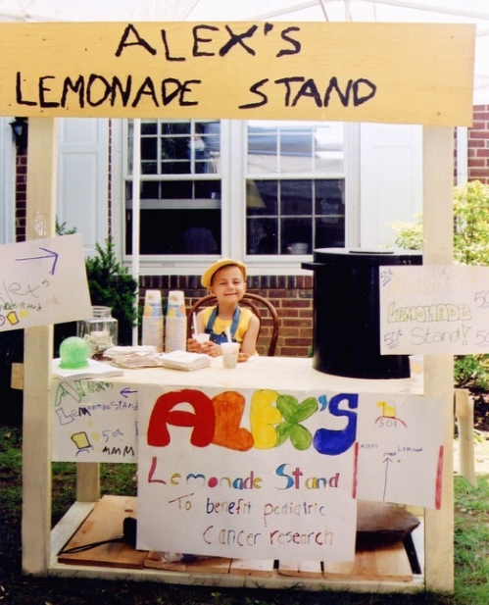
About The Million Mile Virtual Fundraiser
The Million Mile is an annual event in support of Alex's Lemonade Stand Foundation (ALSF). During The Million Mile, teams nationwide join together for Childhood Cancer Awareness Month, September, to log 1,000,000 miles of activity, and raise $1,000,000.
Why join The Million Mile? Bring a common cause to your district, school, or classroom; share the value of philanthropy, and how kids can help kids. Your students can set their own goals – to raise $100, to join a school-wide walk, to wear yellow to raise awareness for childhood cancer - and work towards them together.

How do I participate? Register your team and choose your level of involvement. For a simple addition to your day or school – Send students home with calendars to log their activity for homework; have them raise money at home. For a more involved strategy – incorporate Million Mile into your day or lesson plans; have students reflect on their progress through ‘Do Now’ tasks, or have school assemblies and awareness days to build your school or classroom culture.

There are many ways to incorporate The Million Mile into your school this September. Please see the next page for some Common Core State Standards-aligned ideas in Writing!

About Alex’s Lemonade Stand Foundation

Alex’s Lemonade Stand Foundation (ALSF) is a national childhood cancer foundation dedicated to raising funds for research into new treatments and cures for all children battling cancer and providing support to families of children with cancer.
ALSF was founded by four-year-old Alex Scott, who was diagnosed with cancer shortly after her 1st birthday. She started selling lemonade in her front yard and would go on to raise more than $1 million before she passed away at the age of 8 in 2004.
Today, the movement she started has become one of the largest national pediatric cancer organizations in the United States, having raised more than $150 million towards Alex’s dream of finding a cure, funding over 800 research projects at hospitals across the country.

ALEX'S LEMONADE STAND FOUNDATION FOR CHILDHOOD CANCER

Grade | Domain | CCSS Standard(s) | Classroom Application Ideas
K | Text Types and Purposes | CCSS.ELA-LITERACY.W.K.3  Use a combination of drawing, dictating, and writing to narrate a single event or several loosely linked events, tell about the events in the order in which they occurred, and provide a reaction to what happened. | Draw pictures to represent activities during The Million Mile; use sentence frames to write about these activities and individual reactions to them
1 | Research to Build and Present Knowledge | CCSS.ELA-LITERACY.W.1.7  Participate in shared research and writing projects (e.g., explore a number of "how-to" books on a given topic and use them to write a sequence of instructions).  CCSS.ELA-LITERACY.W.1.8  With guidance and support from adults, recall information from experiences or gather information from provided sources to answer a question. | Write a ‘How-To’ book on taking a walk, riding a bike, tying shoes, swimming, or other activities related to The Million Mile.
2 | Research to Build and Present Knowledge | CCSS.ELA-LITERACY.W.2.7  Participate in shared research and writing projects (e.g., read a number of books on a single topic to produce a report; record science observations).*  *Math and Science integration | Record the outdoor temperature one or more times daily throughout the month of September; include sensory observations; write about cause/effect relationships between weather and clothing or transportation choices; plot temperatures on a graph; analyze maximum, minimum, and range; reflect on potential relationship between temperature and activity level on a given day
3 | Text Types and Purposes | CCSS.ELA-LITERACY.W.3.1  Write opinion pieces on topics or texts, supporting a point of view with reasons. | Produce a Writing piece that includes an opinion on the importance of exercise for kids, and facts to support this opinion.
 | Research to Build and Present Knowledge | CCSS.ELA-LITERACY.W.3.7  Conduct short research projects that build knowledge about a topic.
4 | Text Types and Purposes | CCSS.ELA-LITERACY.W.4.1  Write opinion pieces on topics or texts, supporting a point of view with reasons and information.  CCSS.ELA-LITERACY.W.4.2  Write informative/explanatory texts to examine a topic and convey ideas and information clearly. | Produce a Writing piece with an opinion on the importance of exercise for kids, and facts to support this opinion. Include a list of sources, and take a survey and/or reflect on one’s own activity level throughout the month, to apply this analysis to real-life situations.
 | Research to Build and Present Knowledge | CCSS.ELA-LITERACY.W.4.7  Conduct short research projects that build knowledge through investigation of different aspects of a topic.  CCSS.ELA-LITERACY.W.4.8  Recall relevant information from experiences or gather relevant information from print and digital sources; take notes and categorize information, and provide a list of sources.  CCSS.ELA-LITERACY.W.4.9  Draw evidence from literary or informational texts to support analysis, reflection, and research.
5 | Text Types and Purposes | CCSS.ELA-LITERACY.W.5.1  Write opinion pieces on topics or texts, supporting a point of view with reasons and information.  CCSS.ELA-LITERACY.W.5.2  Write informative/explanatory texts to examine a topic and convey ideas and information clearly.  CCSS.ELA-LITERACY.W.5.3  Write narratives to develop real or imagined experiences or events using effective technique, descriptive details, and clear event sequences. | Write an article about The Million Mile and the idea of ‘kids helping kids’ that includes a clear point of view, relevant facts, and interviews with classmates to support the writer’s argument.
 | Research to Build and Present Knowledge | CCSS.ELA-LITERACY.W.5.7  Conduct short research projects that use several sources to build knowledge through investigation of different aspects of a topic.  CCSS.ELA-LITERACY.W.5.8  Recall relevant information from experiences or gather relevant information from print and digital sources; summarize or paraphrase information in notes and finished work, and provide a list of sources.  CCSS.ELA-LITERACY.W.5.9  Draw evidence from literary or informational texts to support analysis, reflection, and research.
6+ | Grades 6+ can incorporate one or more of the above activities using standards that have built upon K-5 concepts. These students can also split projects among group members to create a collaborative finished product, and practice Speaking and Listening skills with presentations or debates.

