Promoting Your Event
After you determine a date, time, and location for your fundraising event, it is important to get the word out to promote and invite people to the event. Be sure to include clients and prospects on your invite list!
Here are the different ways to promote your event:

Email
You are required to use your Northwestern Mutual email account to communicate with clients and prospects. Below is a sample email invitation you can send to help promote your fundraising event:
Subject: Join us to stand up against childhood cancer!
Body: Please join us [day, date] and take a stand against childhood cancer!
[Name of office] is hosting [name of event or description of event] to benefit Alex’s Lemonade Stand Foundation (ALSF). ALSF funds some of the most promising childhood cancer research in the country.
Northwestern Mutual is committed to giving all kids the chance to live life to the fullest by accelerating the search for better treatments and cures for childhood cancer while supporting families battling the disease and survivors living with life-long effects.
Please join us and invite your family and friends.
When: [date and time of event]
Where: [location of event]
RSVP: click [Eventbrite URL for event]
Note: By clicking the link above, you are entering a site owned and operated by an independent third party, Eventbrite. Any information inputted into Eventbrite’s site, including your name, address and payment information, will be hosted and maintained by Eventbrite and is subject to the policies governing Eventbrite’s site, including the Privacy Policy, Terms of Service and Terms of Use.
If you can’t join us, please consider making a donation to our fundraising page: [ALSF URL fundraising page]
Thank you in advance for your support.
Sincerely,
[auto signature]

Social Media
Northwestern Mutual provides a portal through which you can promote your fundraising events on social media channels, such as Instagram, Facebook, and LinkedIn.
In the social media portal:
- Select Create a Post Toolbox.
- Select the accounts where you want to post and enter your post copy.
- Select the photo option of the pre-approved template and click Select Photo.
- In the pop-up window, select the dynamic image option.
- Select one of the two ALSF templates you want included with your post:
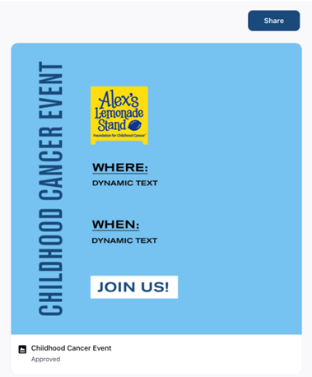

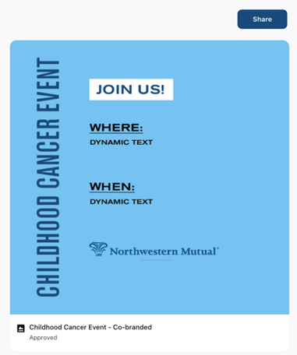

- Update the template with your event details.

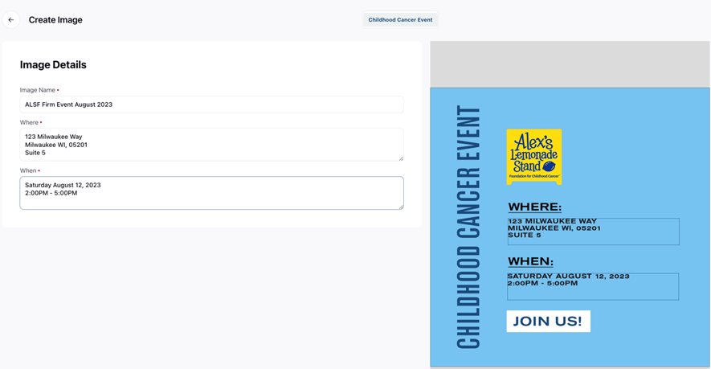

- Click Share when you are ready to post.

Press
Often, media outlets are looking for “feel good” stories and Northwestern Mutual’s local and national support in standing up against childhood cancer is a great story to tell. The following is a media alert template to help provide event information to local media outlets.
Note: Discussions about press should occur prior to the event with Lauren Samaha and Jen Erickson at the home office. Based on those discussions, the best approach for coverage for the event will be decided.
Media alerts and press engagement will be manage by the home office PR team.
Northwestern Mutual – [OFFICE NAME] Hosts [Event Name] in Support of Childhood Cancer Research

WHO: Northwestern Mutual – [OFFICE NAME] is hosting a [event name] in support of Alex’s Lemonade Stand Foundation (ALSF).

WHAT: Northwestern Mutual – [OFFICE NAME] will raise funds for ALSF, contributing to the more than $XXX,XXX the office has raised since dedicating philanthropic efforts to pediatric cancer. Since 2000, ALSF has strived to live out its mission of empowering individuals to fight childhood cancer, one cup of lemonade at a time.
Northwestern Mutual – [OFFICE NAME] has provided [BACKGROUND ON PREVIOUS CHILDHOOD CANCER EFFORTS OF OFFICE].
Through [Event Name], Northwestern Mutual – [OFFICE NAME] strives to help children experience the joy of life while supporting researchers in taking a step closer to finding a cure for cancer.

WHERE: LOCATION
ADDRESS
CITY, STATE, ZIP CODE

WHEN: DAY OF WEEK, MONTH/DATE, TIME (AM/PM) (TIME ZONE)

WHY: Cancer remains the leading cause of death by disease past infancy among children in the United States, yet childhood cancer research and services are vastly and consistently underfunded. Through Northwestern Mutual’s Childhood Cancer Program, it has donated more than $50 million and funded more than 600,000 hours of research since 2012.

CONTACTS:

ON-SITE CONTACT:
[NAME], Northwestern Mutual – [OFFICE NAME]
XXX-XXX-XXXX;
[NORTHWESTERN MUTUAL EMAIL]

