Date: xx/xx/xx
Event Type:
Location:
Hosted by: Northwestern Mutual Network Office
Supports: Alex’s Lemonade Stand Foundation

Event Name
Benefiting

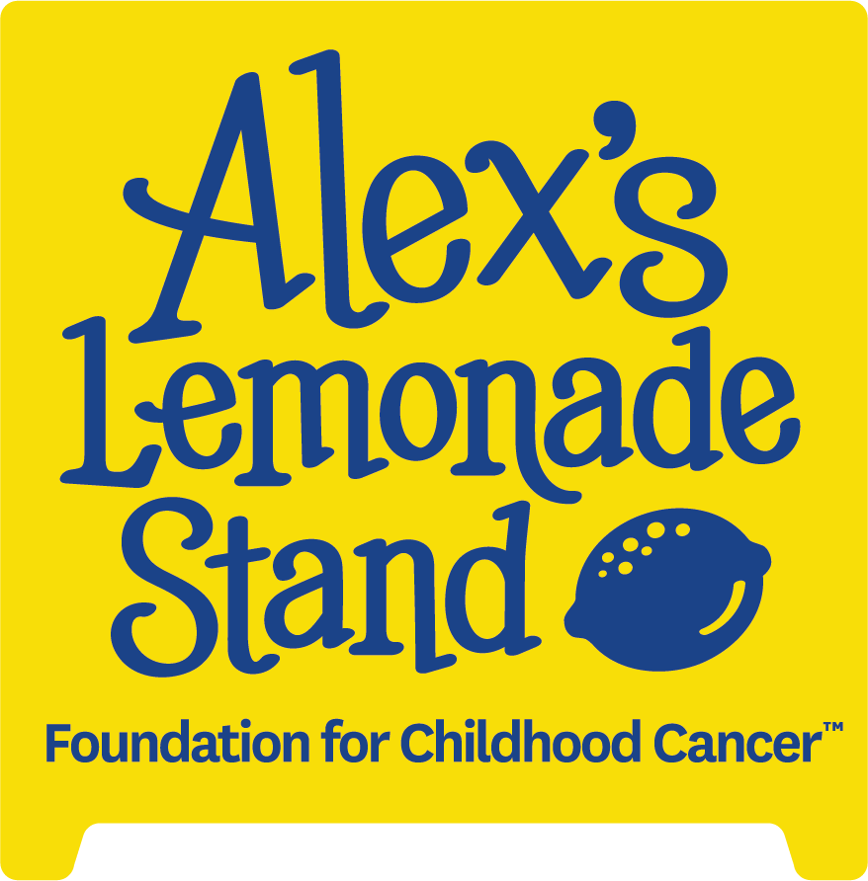

Sponsorship Opportunities – Help Support Childhood Cancer Research

Northwestern Mutual – Network Office Name is excited to help make a difference in the lives of children facing cancer. We are hosting a [event type]. Please join us in our pursuit to support Alex’s Lemonade Stand Foundation and reach our yearly fundraising goal of $xxxxxx.

The success of this great event is in large part due to the generous support we receive from our donors. This year, we’re asking you to join us in our effort to fight childhood cancer by donating to our auction. All money raised from bids will go to support life-saving research projects.

With your gift, you can join us in our endeavor to support Alex’s Lemonade Stand Foundation.

About Alex’s Lemonade Stand:
Alex’s Lemonade Stand Foundation is a national 501(c) non-profit organization with the primary focus to find a cure for all childhood cancers.

They are doing everything they can to speed up progress that will help find these cures, as well as developing resources for childhood cancer heroes and their families as they battle the disease. To date they have raised over $200 million in the fight against childhood cancer and have funded nearly 1,000 research projects.

www.alexslemonade.org
About Northwestern Mutual Network Office Name: For more than 100 years, Northwestern Mutual's [name] network office has worked to help secure and enhance the financial success and well-being of families and businesses in the [geographic location] area.
Our office has nearly $xx billion of life insurance in force, and a field force of more than [number of FRs] Financial Representatives serving clients from [number of] offices in [geographic location]. In addition to offering access to risk management products and solutions, Northwestern Mutual can provide a variety of related products that can help solve personal, retirement, estate and business planning needs.
We believe in doing what’s right. This is evident in the way we do business, in how we work with clients, in the values we hold and in the way we’re working together to strengthen local communities.

[network office URL]

All In-Kind Donations May Be Tax Deductible – Please Consult Your Tax Advisor
Please accept our official pledge; will provide item no later than [date due]

