Date: xx/xx/xx
Event Type:
Location:
Hosted by: Northwestern Mutual Network Office
Supports: Alex’s Lemonade Stand Foundation

Event Name
Benefiting

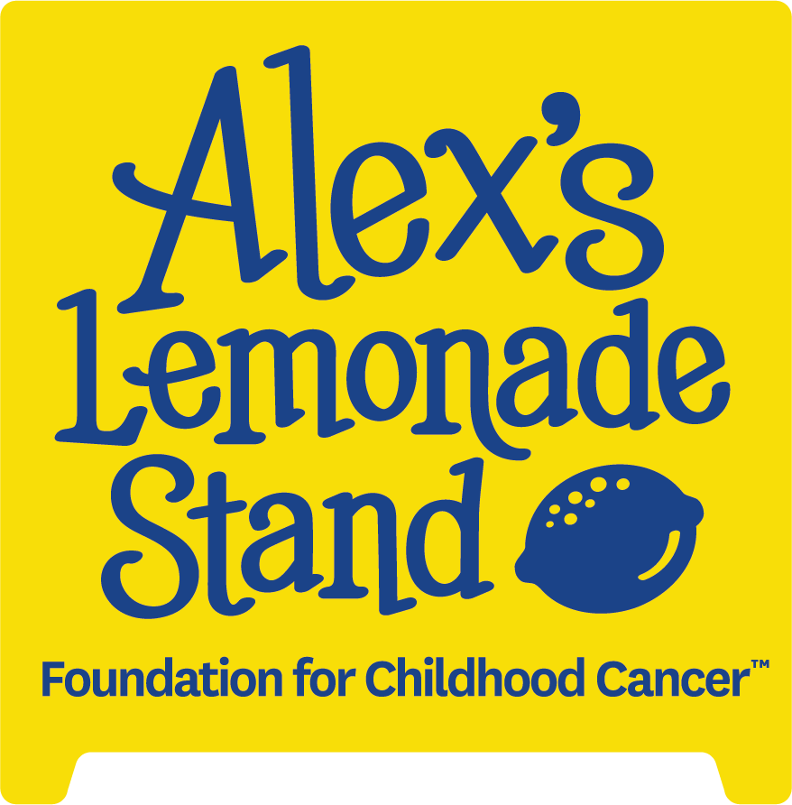

Sponsorship Opportunities – Help Support Childhood Cancer Research

Northwestern Mutual – Network Office Name is excited to help make a difference in the lives of children facing cancer. We are hosting a [event type] with [event details, such as: music, food, a silent auction and more]. Please join us in our pursuit to support Alex’s Lemonade Stand Foundation and reach our yearly fundraising goal of $xxxxxx.

The success of this great event is in large part due to the generous support we receive from our sponsors. This year, we’re asking you to join us in our effort to fight childhood cancer by raising money to support life-saving research projects.

Please take a moment to review the enclosed Sponsorship Opportunities Packet and consider one of the support levels. With your gift, you can join us in our endeavor to support Alex’s Lemonade Stand Foundation.

About Alex’s Lemonade Stand:
Alex’s Lemonade Stand Foundation is a national 501(c) non-profit organization with the primary focus to find a cure for all childhood cancers.

They are doing everything they can to speed up progress that will help find these cures, as well as developing resources for childhood cancer heroes and their families as they battle the disease. To date they have raised over $200 million in the fight against childhood cancer and have funded nearly 1,000 research projects.

www.alexslemonade.org

About Northwestern Mutual Network Office Name: For more than 100 years, Northwestern Mutual's [name] network office has worked to help secure and enhance the financial success and well-being of families and businesses in the [geographic location] area.
Our office has nearly $xx billion of life insurance in force, and a field force of more than [number of FRs] Financial Representatives serving clients from [number of] offices in [geographic location]. In addition to offering access to risk management products and solutions, Northwestern Mutual can provide a variety of related products that can help solve personal, retirement, estate and business planning needs.
We believe in doing what’s right. This is evident in the way we do business, in how we work with clients, in the values we hold and in the way we’re working together to strengthen local communities.

[network office URL]

Please consider one of the sponsorship opportunities enclosed. If you have any questions, please contact [primary contact name, phone number and email address].
[Event Year and Name] Sponsorship Opportunities & Benefits
Sponsorship opportunities are available for corporations, organizations, individuals and families.
$5,000 [Level Name] Sponsor
- 8 tickets to the [event name]
- Logo included on invitation
- Logo on all event promotion materials, including signage at the event
- Mention in online promotion including social media and email communication to Northwestern Mutual clients and prospects
- Ability to include promotional item in Gift Bag
- Included in press releases and media materials related to event
- Included in visual display throughout the event
$2,500 [Level Name] Sponsor
- 4 tickets to the [event name]
- Logo on all event promotion materials, including signage at the event
- Mention in online promotion including social media and email communication to Northwestern Mutual clients and prospects
- Ability to include promotional item in Gift Bag
- Included in press releases and media materials related to event
- Included in visual display throughout the event
$1,000 [Level Name] Sponsor
- 2 tickets to the [event name]
- Logo on all event promotion materials, including signage at the event
- Mention in online promotion including social media and email communication to Northwestern Mutual clients and prospects
- Ability to include promotional item in Gift Bag
- Included in press releases and media materials related to event
- Included in visual display throughout the event
Food Sponsor
Provide in-kind food for up to [number of attendees] people – [food needed, like: light hors d’ouevres], delivered to event, the day of.
- 2 tickets to the [event name]
- Logo on all event promotion materials, including signage at the event
- Mention in online promotion including social media and email communication to Northwestern Mutual clients and prospects
- Ability to include promotional item in Gift Bag
- Included in press releases and media materials related to event
- Included in visual display throughout the event

Drink Sponsor
Provide in-kind beverages for up to [number of attendees] people to be delivered to event location the day of.
- 2 tickets to the [event name]
- Logo on all event promotion materials, including signage at the event
- Mention in online promotion including social media and email communication to Northwestern Mutual clients and prospects
- Ability to include promotional item in Gift Bag
- Included in press releases and media materials related to event
- Included in visual display throughout the event
Decoration Sponsor
Provide tables, chairs, centerpieces, linens or other decorations as negotiated with [Event Name] Committee – to be delivered to the event the day of.
- 2 tickets to the [event name]
- Logo on all event promotion materials, including signage at the event
- Mention in online promotion including social media and email communication to Northwestern Mutual clients and prospects
- Ability to include promotional item in Gift Bag
- Included in press releases and media materials related to event
- Included in visual display throughout the event
Music Sponsor
Provide entertainment/music for the event – all equipment to be delivered to the event the day of.
- 2 tickets to the [event name]
- Logo on all event promotion materials, including signage at the event
- Mention in online promotion including social media and email communication to Northwestern Mutual clients and prospects
- Ability to include promotional item in Gift Bag
- Included in press releases and media materials related to event
- Included in visual display throughout the event

*Sponsor to provide promotional materials and logos. Deadlines apply.
Please register your sponsorship using the attached form.
Event Name
[Year] Sponsorship
Company Name:

Contact Person:
Address: City, State Zip:
E-mail address:
Phone number: Fax number:
PLEASE CHECK THE APPROPRIATE SPONSORSHIP LEVEL
 | [Level Name] Sponsor: | $5,000
 | [Level Name] Sponsor: | $2,500
 | [Level Name] Sponsor: | $1,000
 | Food Sponsor: | In-Kind ($ Value To be Determined)
 | Drink Sponsor: | In-Kind ($ Value To be Determined)
 | Decorations Sponsor: | In-Kind ($ Value To be Determined)
 | Music Sponsor: | In-Kind ($ Value To be Determined)
All In-Kind Donations May Be Tax Deductible – Please Consult Your Tax Advisor
For Cash Donations, Choose One Of These Appropriate Payment Methods
Please accept our official pledge; will submit full payment no later than [date due]
Check is enclosed, made payable to:
Alex’s Lemonade Stand Foundation

Online Donation – Please use the link below to donate through our team donation page:
[ALSF fundraising page URL]

MAIL Checks to: DONOR RETAINS A COPY AS A RECEIPT:
Office Name
Address

Contact: [name, phone number, email address]

