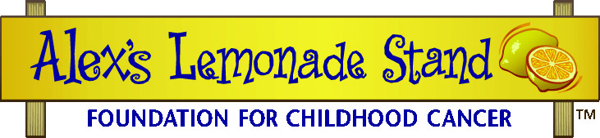

Supply Donations from local businesses
Some local businesses may like to make a donation in the form of money, while others enjoy helping by donating requested supplies. Once you have created a supply list of all the things you will need to run your walk-a-thon, you can try to have some of the things you need donated.

Below is a sample letter asking businesses for local support through donations or products. You can personalize this letter for your own community and event.

Sample Letter to Local Businesses requesting support

Dear Business Owner,

As a local supporter of Alex’s Lemonade Stand Foundation, a nationally recognized nonprofit organization dedicated to finding a cure for childhood cancer, I am writing to ask you to contribute to our walk-a-thon. Our walk-a-thon is part of a national project to raise awareness and money for childhood cancer research. I am hoping you will consider making either a monetary or product donation to help us beat childhood cancer. All donations are tax deductible.

Alexandra “Alex” Scott (1996-2004), the founder of Alex’s Lemonade Stand Foundation, was just 4-years-old when she came up with the idea to raise money for childhood cancer through holding lemonade stands. Having been diagnosed with an aggressive form of childhood cancer shortly before her first birthday, Alex set up her first stand in her front yard to help raise money for research.

Alex had a keen sense of understanding, and knew that the only way children with cancer had a chance to live longer lives was to increase funding for researchers in order to pursue better treatment options. For over seven years, Alex underwent an innumerable amount of experimental treatments in the hopes that one day the doctors would find that cure. Cancer ultimately took Alex’s life when she was 8 years old, but she left behind a legacy of hope and a foundation bearing her name – Alex’s Lemonade Stand Foundation.

To help you understand the urgent need for funding, here is a staggering statistic: cancer is the leading cause of death by disease in children in the United States today. By holding an Alex’s Lemonade Stand in our community, we are carrying on Alex’s dream to help find better treatments and ultimately cures, something that is vastly overlooked. We need your help.

Since Alex’s first lemonade stand in 2000, over $25 million has been raised by children, families, schools, businesses and organizations across the country. We hope you will choose to join the national endeavor to fight childhood cancer one cup at a time.

Sincerely,

Your Community Host for Alex’s Lemonade Stand Foundation

Thank you to Supporters
At your walk-a-thon, you can thank supporters and sponsors by posting a sign listing their names or using their logo on any materials (such as posters or shirts) that you make for your walk-a-thon.
Once your walk-a-thon is complete, make sure to thank all of your supporters, especially any businesses who made donations. It is great for them to see your appreciation for the help you gave. Below is a sample thank you letter which you can personalize.

Sample Thank you Letter to Business Owners
Dear Business Owner:

On behalf of Alex’s Lemonade Stand Foundation for Childhood Cancer, I would like to thank you for your contribution to our walk-a-thon.

Alex’s Lemonade Stand Foundation (ALSF) grew out of the front yard lemonade stand of childhood cancer patient Alexandra “Alex” Scott. In 2000, at the age of 4, Alex held her first lemonade stand with the hope of raising money for pediatric cancer causes, specifically research leading to a cure. Alex passed away in 2004, but her legacy continues through the Foundation that bares her name and thousands of volunteers across the country who carry on her mission.

We had a great time at our walk-a-thon, and raised XXX to be used for childhood cancer research. We could not have been so successful without your help! Every step we took and dollar we raised gets us closer to finding a cure.

For more information about Alex’s Lemonade Stand Foundation and its mission, visit www.AlexsLemonade.org or call toll free (866) 333-1213.

With gratitude,

Your Community Host for Alex’s Lemonade Stand Foundation

