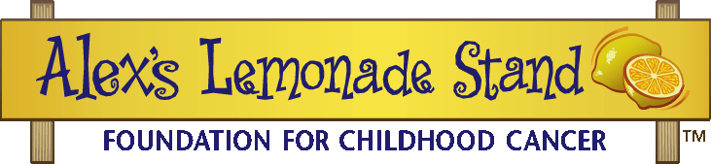
Fighting childhood cancer, one cup at a time.

<<Month/Day/Year>>
Dear Parents and Guardians,

We are so excited to announce that <<School Name>> has partnered up with Alex’s Lemonade Stand Foundation (ALSF) to raise money for much needed children cancer research. ALSF emerged from the front yard lemonade stand of cancer patient Alexandra “Alex” Scott (1996-2004). In 2000, 4-year-old Alex announced that she wanted to hold a lemonade stand to raise money and help find a cure for all children with cancer. Since Alex held that first stand, the Foundation bearing her name has evolved into a national fundraising movement, complete with thousands of supporters across the country carrying on her legacy of hope. To date, ALSF, a registered 501(c)3 charity, has raised more than $140 million toward fulfilling Alex’s dream of finding a cure, funding over 690 pediatric cancer research projects nationally.

If Alex taught us anything, it’s that anybody at any age can make a difference. Carrying on the legacy of Alex and so many after her, they are kids helping kids. Through <<Fundraising Efforts>>, <<School Name>> will be raising money to fight childhood cancer on <<Event Date>>.

Please feel free to explore AlexsLemonade.org with your child to find out more about ALSF, or if you would like to get involved as a family. We are looking forward to a successful and fun event! If you have any questions, please contact <<Teacher Name>>.

Best,
<<Name>>

Alex’s Lemonade Stand Foundation
111 Presidential Blvd, Suite 203, Bala Cynwyd, PA 19004 * p-(610) 649-3034 * f-(610) 649-3038
AlexsLemonade.org

